Abdi Abera
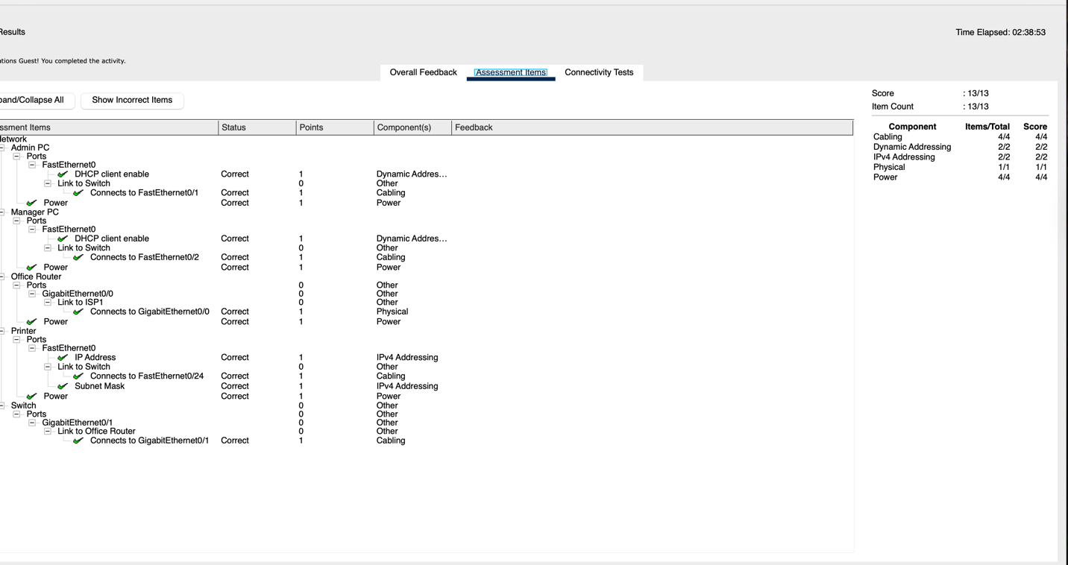
Step1c. The printer does not require a default gateway because it will only be accessed by hosts on the local network. However, if you need to configure it with a default gateway, which value will the printer use? How can you determine this from the other devices in the network?
Ans:
the router g0/1 interface and the ipv4 192.168.1.1
we can determine using ipconfig is the most important to see what is going on with ip’s
Step2 If you can connect by the IP address, but not by the URL, what do you think is the cause of this problem?
Ans: if DNS fails it means all the pc cannot translate the links into Ip address.
Part4step1 : Open a command prompt on one of the PCs and enter the ipconfig command and make note of the information that is returned. Now enter the ipconfig /all command. What additional information is displayed?
Ans: it show all the ip’s and bluethooth connection
Bluetooth Connection:
Connection-specific DNS Suffix..:
Link-local IPv6 Address.........: ::
IPv6 Address....................: ::
IPv4 Address....................: 0.0.0.0
Subnet Mask.....................: 0.0.0.0
Default Gateway.................: ::0.0.0.0
Part4step2. How many routers are passed on the way to the destination? How are those routers identified?
Where is the second router located?
Ans: 2 routers and the second one is ISP

Consider a small office that has a LAN like the one you have created here. What is the biggest facilities challenge in setting up the network in a new location?

Ans: I may say the cabling, location which is secure area, the power supply, and etc

